PATENT QUOTATION
Dated: 31/07/2025
Addressed to: The Principal, Canara Engineering college Mangalore
Quotation Prepared by: Adv. Pranav Bhat
Contact Details: 9035685434
Email: an.astraea@gmail.com / pranavbhat334@gmail.com
Sl. No | Particulars | Cost (Govt Fee + Prof Fee + Misc.)
1. | Patent searching with oral opinion and direct filing of Complete specification draft, and Request for Early Publication Only | 4,100+14,450+550 = 19,100/-
2. | Patent searching with oral opinion and direct filing of Complete specification draft, and Request for Early Publication till grant without hearing | 8,100+38,900+1,100 = 48,100/-
3. | Patent searching with oral opinion and direct filing of Complete specification draft, and Request for Early Publication till grant with hearing | 8,100+54,900+1,100 = 64,100/-

Notes:
- An 18% GST will be applied to the professional fees.
- In case a similar quotation is required again for any other service, kindly reach out to us, and we will be happy to assist you.
- Any additional reimbursements, if applicable, will be informed to you priorly for your approval before proceeding.
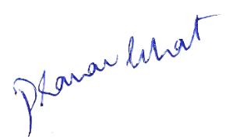

Should you have any questions or require further clarification, please feel free to contact us at the provided email or phone number. Thank you for considering our services. We look forward to assisting you with your intellectual property needs.

Best Regards,
Adv. Pranav Bhat, Chief IP Strategist
Lextria Research

